LOAM

Laser Odometry and Mapping (LOAM) was presented by Zhang and Singh [11] in 2014 and is a real-time algorithm for state estimation using 3D Lidar. To date, LOAM achieves the best odometry estimate using KITTI benchmark data set of all range-only SLAM solutions. Thus, it should be considered state of the art. This SLAM solution achieves low/drift and low/computational complexity through dividing the SLAM problem into two concurrent algorithms. One algorithm performs odometry at a high frequency and low fidelity to estimate the velocity of the 3D Lidar. The other runs at a 1/10 of said frequency for fine matching and point cloud registration.

Both are based on feature extraction and feature matching. The features extracted are points located on sharp edges and planar surfaces. The odometry algorithm returns a 6-DOF rigid motion through finding correspondences between edges and edge line segments, and correspondences between planar surfaces and planar patches. To ensure fast computation, the features extracted are limited.

LIDARs are spinning as they emit laser beams. If the LIDAR experiences motion, as they will I mounted on mobile robots or vehicles, a range measurement at 0 degrees will be made at a different robot location than a range measurement at say 359 degrees. This leads to a distortion of the resulting point cloud registered when a LIDAR revelation is complete. The odometry algorithm uses said 6-DOF rigid motion to create an undistorted version of the point cloud, and feeds this to the mapping algorithm.

The mapping algorithm then performs feature extraction on the point cloud, only this time 10 times as many. The correspondences this time, are found by examining geometric distributions of local point clusters, through the associated eigenvalues and eigenvectors. A rigid transformation is obtained from the mapping algorithm as well, and the LIDAR with respect to the map is a combination of the two transformations, calculated at the same frequency as the odometry algorithm.

LOAM can be supplemented with IMU data if available. This can, help reduce the error by fusing simulated orientation integrated from gyro sensor data, as well as disposing unnecessary frames. However, unless the LIDAR experiences very large motions, this is stated by (loam-paper
as unnecessary.

Additional advantages has been made to the LOAM approach since the release of the 2014 paper, and more sophisticated SLAM algorithms have been incorporated into the solution. However, the author has since commercialized the findings through self-founded KAARTA, formerly Real Earth. The company delivers products for real-time mobile mapping. A result of this is that open-source code related to LOAM has been removed, and is officially unavailable to the public. What is available, is laboshinl’s Git repository, who wrote his master thesis on the subject of Quantifying Aerial LIDAR Accuracy of LOAM for Civil Engineering Applications. The repository contains a copy of the source code for LOAM, modified to the Velodyne VLP-16 LIDAR, as it originally was designed for a custom made rotating 2D-LIDAR.

The “available” LOAM-version shows promising map building both for UGVs indoors and outdoors and for UAV. Note that the goal of the algorithm is primarily mapping, and loop closure is not accounted for. However, since the pose of the LIDAR is provided through the transformations, the algorithm was deemed worth testing.

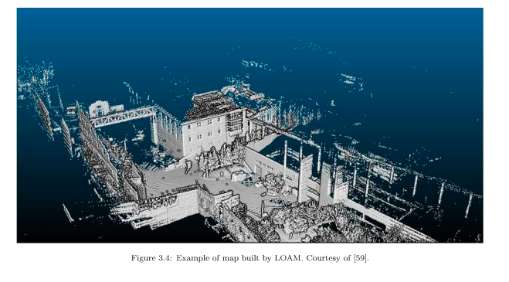

Bibliography

[11] J. Zhang and S. Singh, “Lidar Odometry and Mapping in Real-time”

